2. Conceptual Model

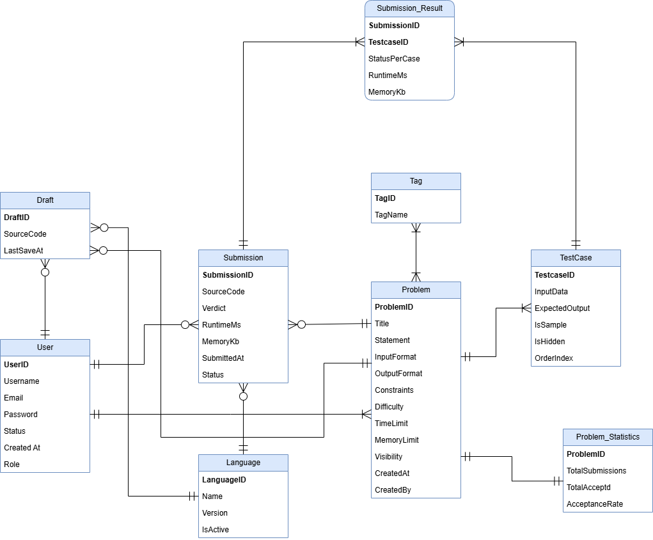

4. Data Design
4.1. Data Diagram
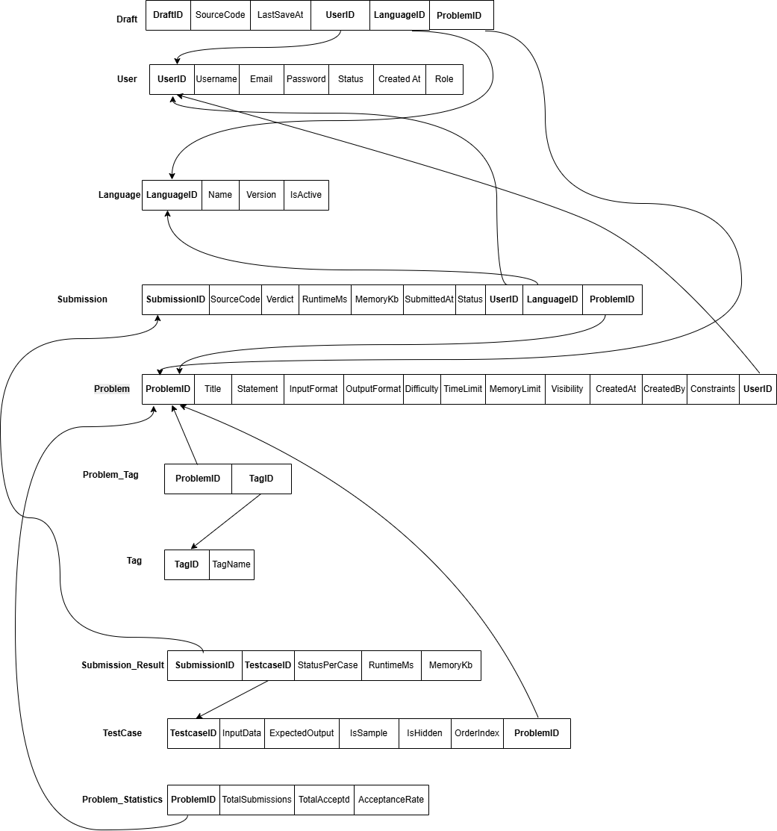

4.2. Data Specification
In this section, we describe the logical data model of the system and provide detailed specifications of all database tables used for data storage. For each table, the corresponding data columns are listed together with their attribute names, data types, value constraints, key constraints (primary keys and foreign keys), as well as a short explanation of the attribute’s meaning and purpose within the system.
This specification serves as the foundation for implementing the physical database schema in the chosen Database Management System (DBMS) and ensures that the data structure consistently supports the system’s functional and non-functional requirements

4.2.1 Table: USER
Description: Store information about all system users (students, problem setters, administrators)

Column | Data Type | Constraints | Description
UserID | INT | PK, AUTO_INCREMENT, NOT NULL | Unique identifier of the user.
Username | VARCHAR(50) | UNIQUE, NOT NULL | Login name of the user.
Email | VARCHAR(100) | UNIQUE, NOT NULL | Email address used for registration and contact.
Password | VARCHAR(255) | NOT NULL | Encrypted password of the user.
Role | ENUM('student','setter','admin') | NOT NULL | Role of the user in the system.
Status | ENUM('active','banned','inactive') | NOT NULL DEFAULT 'active' | Account status.
CreatedAt | DATETIME | NOT NULL | Account creation timestamp.

4.2.2 Table: PROBLEM
Description: Store programming problems available in the system

Column | Data Type | Constraints | Description
ProblemID | INT | PK, AUTO_INCREMENT, NOT NULL | Unique identifier of the problem.
Title | VARCHAR(150) | NOT NULL | Title of the problem.
Statement | TEXT | NOT NULL | Full description of the problem.
InputFormat | TEXT | NOT NULL | Description of the input format.
OutputFormat | TEXT | NOT NULL | Description of the required output format.
Constraints | TEXT | NULL | Problem constraints (limits on input size, …).
Difficulty | ENUM('easy','medium','hard') | NOT NULL | Difficulty level of the problem.
TimeLimit | INT | NOT NULL | Time limit per test case (in milliseconds)
MemoryLimit | INT | NOT NULL | Memory limit per test case (in kilobytes)
Visibility | ENUM('public','private','hidden') | NOT NULL DEFAULT 'public' | Visibility of the problem
CreatedAt | DATETIME | NOT NULL | Problem creation timestamp.
CreatedBy | INT | NOT NULL, FK → USER(UserID) | User who created the problem (setter or admin)

4.2.3 Table: TAG
Description: Store tags used to categorize problems

Column | Data Type | Constraints | Description
TagID | INT | PK, AUTO_INCREMENT, NOT NULL | Unique identifier of the tag.
TagName | VARCHAR(50) | UNIQUE, NOT NULL | Name of the tag (for example: Array, DP).

4.2.4 Table: PROBLEM_TAG
Description: Link table for many-to-many relationship between PROBLEM and TAG

Column | Data Type | Constraints | Description
ProblemID | INT | PK, NOT NULL, FK → PROBLEM(ProblemID) | Linked problem
TagID | INT | PK, NOT NULL, FK → TAG(TagID) | Linked tag

4.2.5 Table: TEST_CASE
Description: Store test cases used to judge each problem

Column | Data Type | Constraints | Description
TestCaseID | INT | PK, AUTO_INCREMENT, NOT NULL | Unique identifier of the test case.
ProblemID | INT | NOT NULL, FK → PROBLEM(ProblemID) | Problem that this test case belongs to.
InputData | TEXT | NOT NULL | Input data for the test case.
ExpectedOutput | TEXT | NOT NULL | Expected correct output for the test case.
IsSample | BOOLEAN | NOT NULL DEFAULT 0 | TRUE if this is a sample test shown to the user.
IsHidden | BOOLEAN | NOT NULL DEFAULT 1 | TRUE if this test is hidden (used for judging).
OrderIndex | INT | NOT NULL | Order of the test case within the problem.

4.2.6 Table: LANGUAGE
Description: Store programming languages supported by the system

Column | Data Type | Constraints | Description
LanguageID | INT | PK, AUTO_INCREMENT, NOT NULL | Unique identifier of the language.
Name | VARCHAR(50) | NOT NULL | Language name (For example, C++, Python, Java).
Version | VARCHAR(20) | NULL | Version of the language (For example, C++17)
IsActive | BOOLEAN | NOT NULL DEFAULT 1 | Whether the language is currently enabled.

4.2.7 Table: SUBMISSION
Description: Store each submission made by users for problems.

Column | Data Type | Constraints | Description
SubmissionID | INT | PK, AUTO_INCREMENT, NOT NULL | Unique identifier of the submission.
UserID | INT | NOT NULL, FK → USER(UserID) | User who made the submission.
ProblemID | INT | NOT NULL, FK → PROBLEM(ProblemID) | Problem being submitted.
LanguageID | INT | NOT NULL, FK → LANGUAGE(LanguageID) | Programming language used.
SourceCode | MEDIUMTEXT | NOT NULL | Submitted source code.
Verdict | ENUM('Accepted','Wrong  Answer','Time Limit Exceeded','Memory Limit Exceeded','Runtime Error','Compilation Error','System Error') | NULL | Final result after judging.
RuntimeMs | INT | NULL | Total execution time across tests (milliseconds).
MemoryKb | INT | NULL | Peak memory usage (kilobytes).
Status | ENUM('Pending','Queuing','Judging','Done','Error') | NOT NULL DEFAULT 'Pending' | Processing status of the submission.
SubmittedAt | DATETIME | NOT NULL | Time when the submission was created.

4.2.8 Table: SUBMISSION_RESULT
Description: Store detailed results of each submission on each test case

Column | Data Type | Constraints | Description
SubmissionID | INT | PK, NOT NULL, FK → SUBMISSION(SubmissionID) | Related submission.
TestCaseID | INT | PK, NOT NULL, FK → TEST_CASE(TestCaseID) | Related test case.
StatusPerCase | ENUM('Passed','Failed','Time Limit Exceeded','Memory Limit Exceeded','Runtime Error') | NOT NULL | Result of this submission on the test case.
RuntimeMs | INT | NULL | Execution time on this test case (milliseconds).
MemoryKb | INT | NULL | Memory usage on this test case (kilobytes).

4.2.9 Table: DRAFT
Description: Store temporary draft code that users save but do not submit yet

Column | Data Type | Constraints | Description
DraftID | INT | PK, AUTO_INCREMENT, NOT NULL | Unique identifier of the draft.
UserID | INT | NOT NULL, FK → USER(UserID) | User who created the draft.
ProblemID | INT | NOT NULL, FK → PROBLEM(ProblemID) | Problem related to the draft.
LanguageID | INT | NOT NULL, FK → LANGUAGE(LanguageID) | Language used in the draft.
SourceCode | MEDIUMTEXT | NOT NULL | Draft source code.
LastSavedAt | DATETIME | NOT NULL | Last time the draft was saved.

4.2.10 Table: PROBLEM_STATISTICS
Description: Store aggregated statistics for each problem

Column | Data Type | Constraints | Description
ProblemID | INT | PK, NOT NULL, FK → PROBLEM(ProblemID) | Problem to which the statistics belong
TotalSubmissions | INT | NOT NULL DEFAULT 0 | Total number of submissions for the problem.
TotalAccepted | INT | NOT NULL DEFAULT 0 | Total number of accepted submissions.
AcceptanceRate | DECIMAL(5,2) | NULL | Acceptance rate (percentage).

